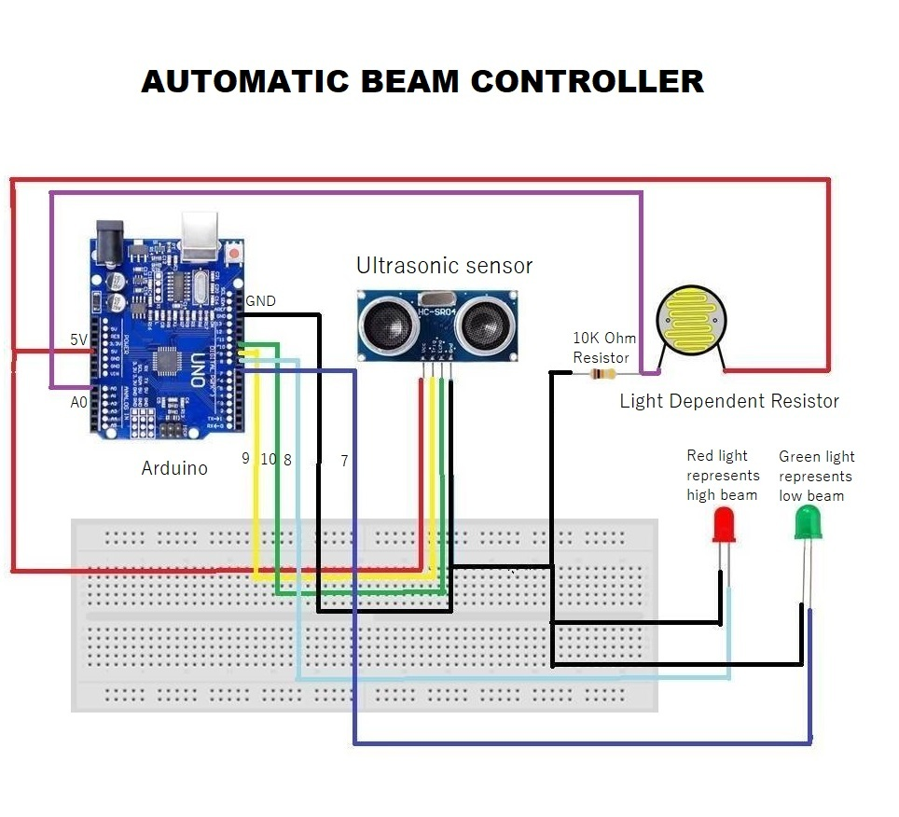

**Components Required:**

1. Arduino
2. Ultrasonic sensor
3. Light dependent resistor(LDR)
4. 10k ohm resistor
5. Two LED’s (Red & Green)
6. Bread board
7. Jumper wires

**Procedure:**

1. Place the Ultrasonic sensor and LDR on the bread board.
2. Connect the 5V of arduino to the VCC of Ultrasonic sensor and to one of the terminal of LDR.
3. Place 10k ohm resistor at other terminal of LDR, and also connect the analog A0 pin to it.
4. Connect ground of arduino to gnd of ultrasonic sensor and other terminal of 10k ohm resistor.
5. Connect digital pin 10 of arduino to the echo pin of ultrasonic sensor.
6. Connect digital pin 9 of arduino to the trig pin of ultrasonic sensor.
7. Connect digital pin 8 of arduino to the Red LED’s positive terminal, and other terminal to ground.
8. Connect digital pin 7 of arduino to the Green LED’s positive terminal, and other terminal to ground.
9. Run the code using arduino IDE.

**Observation:**

Red light represents High beam and Green light represents Low beam. When Ultrasonic sensor detects any object(vehicle) and LDR detects light(beam) then high beam switches to low beam, else it remains in high beam.